Property Management Platform
Main Requirements

This document will help us to get your Elina Property Management Platform set up and ready to go.

The sooner we can get this information back from you, the quicker we can progress with your set up, if you have any questions, please do not hesitate to contact us.

Getting Started
Alongside the completion of details in this document please also share the following supporting documentation with us that should be submitted alongside this document:

1 | Property Setup  - Tab 1 of the spreadsheet should be completed with details relating to your available accommodations.  Super Users  - Tab 2 of the spreadsheet should be completed wtih details relating to your super users who are responsible for creating other user profiles. | ☐  ☐
2 | Business logo in hi-res format: Please send this to us in PNG file format by email. | ☐
3 | An example of your invoice template header (logo, company details etc. See example in Appendix 1) | ☐
4 | If you are using the Elina Booking Engine:  - Your booking terms and conditions (including booking conditions, cancellation policy, payment failure, changes & refunds policy etc..). If you have a perference for the formatting of this information please send us the an already formatted HTML, otherwise we will use our standard format.  - Your booking confirmation page content (information that shows as soon as the booking is confirmed)  For an example of these 2 requirements, see Appendix 2 | ☐  ☐
Please note: all email and invoicing templates can be further customized at a later stage.
For now, let’s get you started!

General Information
Business name (official):
Brand name (this will also become the name of your Elina platform):
Business Address:
Business Phone:
Business Email:
E-mail address from which booking confirmations will be sent:
Website:
Contact for Elina PMS Implementation & Training:
Job Title:
Email:
Phone:
Skype:
Initial list of contact names and email addresses for recipients of the Elina newsletter and release communications
Invoicing & Accounts Set-up
Currency to be used:
VAT rates (%):

Accepted Payment Methods | Please indicate your accepted payment methods  ☐ Bank Transfer  ☐ Cash  ☐ Credit Card  ☐ Other Click to enter details here
Booking Invoice Rules: | Please indicate your default system payment rule here. Note that further rule options will be discussed during your training and system set up  ☐ Example: 50% on booking 50% on arrival  ☐ Example 2: 100% on booking  ☐ Example 3: 100% on departure  ☐ Other Click to enter details here
Booking Defaults – update as required
Default length of stay setting (how many nights do the majority of guests stay with you?): |  | 1 night/s
Default number of guests (how many guests stay per accommodation the majority of time?): |  | 2 guests
Default check-out time: |  | 12h00
Booking Source Codes (used for reporting tools) |  | Default list:  Web (mandatory system code used for online bookings)  Web - Indirect  Further examples (check as required)  ☐ Direct (Email / Phone / In Person)  ☐ Repeat Customer  ☐ Referral  ☐ OTA - booking.com  ☐ OTA - Expedia  ☐ Travel Agent  ☐ Corporate  ☐ Advertising  ☐ Walk-In  ☐ Groups  If you require other booking source options click to enter details here
Company Types |  | When creating company profiles in the CRM module of Elina you will be required to select a company type. This can be used in the Elina marketing tool to target persons related to these company types.  Default list:  ☐ Association  ☐ Charity  ☐ Corporation  ☐ Public Sector  ☐ Private Company  ☐ Organisation  ☐ Travel Agent  If you prefer to create your own more relevant list click to enter it here
Booking Template: Registration Form
Disclaimer to be displayed at the bottom of the standard Elina registration form: |  | Please provide the text disclaimer to show at the bottom of the standard Elina registration form (see example below)  ☐ Select default text  ‘I guarantee to settle my bill and any extra charges that incur during my stay. I understand that I am liable for damages caused, willfully or accidentally, to the property during my stay and I agree that my credit card will be charged directly.’  ☐ Select custom text  Click to Enter your alternative text here  For a full customisation, please send a copy of your desired template design by email.  Sample Elina Registration Card:  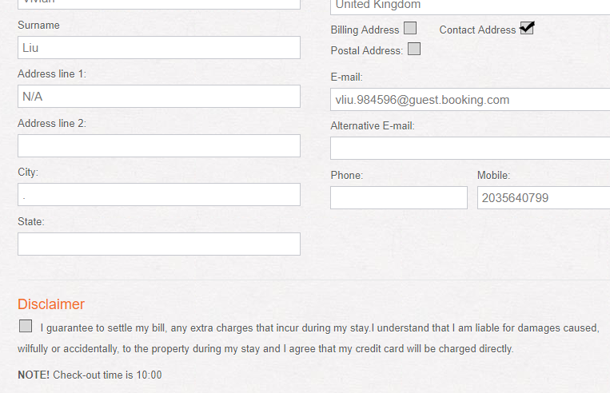
Booking Template: Confirmation & Quote Templates
Your booking confirmation emails: |  | Elina email confirmations will be sent:  From (the email address the email should be sent from)  Bcc (note only one email address can receive a duplicate copy of a reservation)  Subject (e.g. “Your Booking Confirmation at ABC Company”)  Email content  The Elina email confirmation template is made up of four sections:  - Header – this will contain a header image of your choosing. If you do not wish / are not able to provide us one at this point we will use your logo (and can change the image for you later on).  - Reservation Details – we will use our default so do not require any input from you at this stage.  - Useful Information Before You Arrive - we recommend including a short version of your payment terms and cancellation policy, “what happens next”, useful tips, arrival information, etc. Please send this content to us in a separate word document.  - Footer – this will contain your logo and contact details i.e. address, phone etc. We will use the information you have provided in the General Information section of this document unless specified otherwise.  Please provide the above content to us in a separate file in word format  Sample Email Confirmation Template:  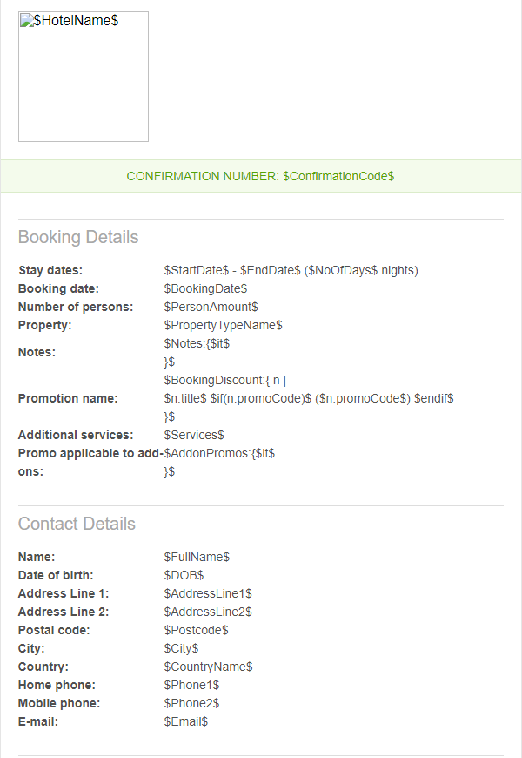  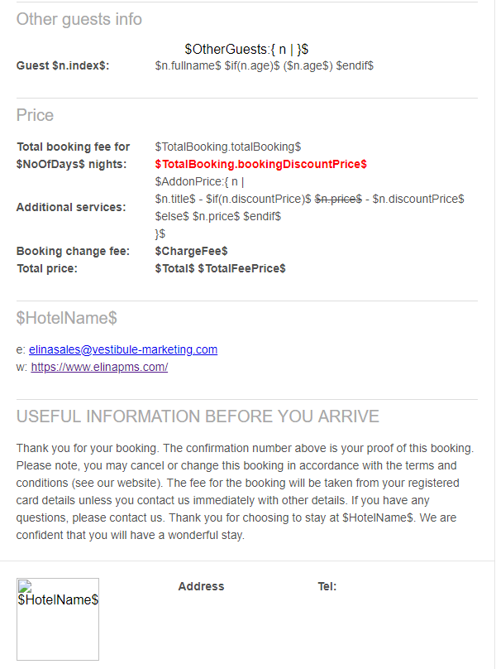
Your booking quote email & links |  | You have the option to send booking quotes to potential bookers either by email or by issuing a link to them. The potential booker can then confirm these by entering their credit card details and thereby convert the quote into a real booking.  Booking Quote email content (select default or enter custom text)  ☐ Please see the details of your price quote below - this is not yet a booking! In order to make a booking based on this quote, please use this link to complete your booking, or contact us directly  ☐ Click to enter your alternative text here  Booking Quote link content  ☐ This booking is not yet confirmed. The availability and rates shown in this quote are subject to overall availability and may no longer be valid. Please click "Confirm and Book" at the bottom to confirm your stay  ☐ Click to enter your alternative text here  Booking Quote Link content - rates no longer valid  ☐ The quoted rates are no longer valid. Please check our up-to-date rates by clicking "Try New Search" button at the bottom of this page.  ☐ Click to enter your alternative text here  Booking Quote Link content - no more availability  ☐ The availability is no longer valid. Please check our up-to-date availability by clicking on "Try New Search" at the bottom of this page.  ☐ Click to enter your alternative text here  Booking Quote Link content - quote expired  ☐ We are sorry but the details of this quote are no longer valid or available. This may have happened as either we no longer have availability for your selected accommodation, or the rates quoted are no longer valid. Please use the new availability search below to see alternatives or contact us directly for another quote. We apologise for any inconvenience, and hope you will take a moment to review other available options!  ☐ Click to enter your alternative text here
Account Activation / Terms and Conditions
Account Registration |  | Please provide the text that you want displayed during the customer account registration with regard to the marketing disclaimer (see example below)  Marketing Disclaimer text  ☐ Allow ‘NAME OF COMPANY’ to send you special offers and newsletters. Your details will not be shared with third parties  ☐ Click to enter your alternative text here
Account activation email  (sent when a new account is created for a guest): |  | Account Activation emails sent to your booked guests to be sent:  From (the email address the email should be sent from)  Subject (e.g. “Your Account Information with ABC Company”)  Email content  Hello, GUEST NAME  Thank you for visiting us at www.companyname.com. We have automatically created an account for you so that you can review your orders, bookings and activity with us online, 24 hours a day. As you log in, you will also have access to special offers and the best prices. To set your password and have a look, please follow this link:  http://elinademo.vestibulesolutions.com/resetpwd?user  We hope you enjoy your stay with us at the Company Name, and look forward to welcoming you soon.  Kind regards, The Company Name Team
Reset password email  (sent when a new password has been requested by or on behalf of a guest): |  | Password re-set emails to be sent:  From (the email address the email should be sent from)  Subject (e.g. “Password re-set request - ABC Company”)  Email content  Hello, GUEST NAME  You recently requested to reset your password. To change your password, follow the link below:  http://elinademo.vestibulesolutions.com/resetpwd?user=laurette&c=kqtvwran12b0hha0lf06j8hn16pzsrr2&redirect=  If you did not reset your password, please disregard this message.  Kind regards, The Company Name Team

Please send all completed documents (see page 2) with this form to:

elinacares@elinapms.com

Should you have any queries regarding the documentation please do not hesitate to contact us either by email or telephone on +44 20 305 17 305 (option 2) and we will be happy to assist.

APPENDIX 1: Sample Invoice Header

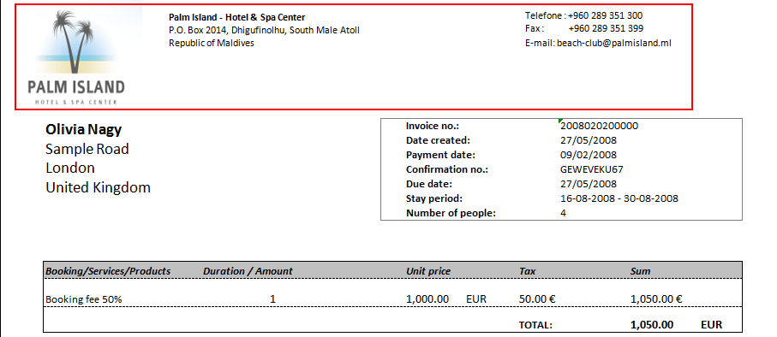

APPENDIX 2: Sample Booking Engine Requirements

Terms and Conditions

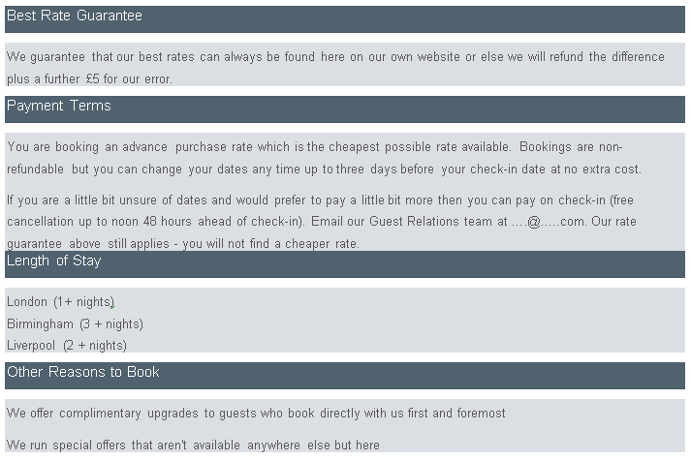

Thank You: Your Confirmation Number
